INDONESIA RENEWABLE ENERGY OUTLOOK: WHAT WE SHOULD EXPECT IN THE FUTURE RENEWABLE ENERGY OF INDONESIA ?

Ian Kurniawan*, Reisya Ichwani**, Richa Fionasari***, Aryansyah****, Adri Huda*****
*Department of Chemical Engineering, Faculty of Engineering, Universitas PGRI-Palembang, Palembang, Indonesia
**Department of Material and Mechanical Engineering, Worcester Polytechnic Institute, Worcester, Massachusetts
***Language Center, Universitas Riau, Pekanbaru, Indonesia
****Department of Energy, Ministry of Energy and Mineral Source of the Republic of Indonesia, Palembang, Indonesia
*****Department of Environmental Engineering, Faculty of Engineering, Universitas Sumatera Utara, Medan, Indonesia
Email Correspondence : adrihuda@usu.ac.id

Received : Accepted : Published :

Abstract: The government of the Republic of Indonesia has reported that Indonesia potentially have more than 400.000 Megawatts (MW) of renewable energy by 2021. However, there is no comprehensive study about the trend of development and priority movement in the renewable energy sector. The main reason for the absence of this study is the lack of significant information and reports on the prospects for renewable energy in Indonesia. The present study aims to provide a basic understanding of renewable energy sector growth in Indonesia. The study uses quantitative analysis with the secondary data obtained from the literatures. The result showed that the hydropower plant contributed the highest energy production in Indonesia followed by bioenergy, solar energy, and wind energy. Furthermore, the production trends of hydropower plants and bioenergy were relatively stagnant over the last 11 years, and the highest significant improvement was found in the solar energy sector. However, the number of solar energy production was far away from the targeted goal in RUEN (National Energy Master Plan/Rencana Utama Energi Nasional) 2017. The high cost of the solar energy sector become the main reason for the unsuccessful development of solar energy in Indonesia. Furthermore, several administrations and regulations were found to the political reason which delay the energy transition improvement. The result showed that the government of the Republic of Indonesia need to revise and form better regulation to boost the number development of renewable energy in Indonesia. In this paper, several discussions were made to give an understanding of where the renewable energy sector should be made in the future.
Keywords: Renewable Energy; Energy Policy; Energy Transition; Green Technology Indonesia

Abstrak: Pemerintah Republik Indonesia telah melaporkan bahwa Indonesia memiliki potensi lebih dari 400.000 Megawatts (MW) Energi Baru dan Terbarukan (EBT) di tahun 2021. Namun, penelitian terhadap pola pengembangan dan pergerakan pengembangan EBT masih belum banyak ditemukan. Alasan utama dari tidak ditemukan penelitian ataupun studi tentang potensi EBT di Indonesia adalah keterbatasan informasi dan laporan terhadap prospek EBT di Indonesia. Studi ini bertujuan untuk menyediakan pemahaman dasar dari perkembangan sektor EBT di Indonesia. Studi ini menggunakan analisis kuantitatif dengan menggunakan data sekunder yang diperoleh dari berbagai literatur. Hasil menunjukkan bahwa Pembangkit Listrik Tenaga (PLT) Air menjadi sektor yang paling banyak memproduksi EBT di Indonesia disusul oleh PLT Bioenergi, PLT Surya, dan PLT Bayu. Namun, pola produksi energi menunjukkan PLT Air dan PLT Bioenergi menunjukkan produktivitas yang relative tetap pada 11 tahun terakhir dimana peningkatan produktivitas terbesar berada pada PLT Surya. Namun, jumlah produktivitas PLT Surya masih tergolong kecil jika dibandingkan dengan jumlah produksi target yang dilaporkan pada Rancangan Utama Energi Nasional (RUEN) 2017. Biaya yang tinggi dari PLT Surya menjadi alasan utama dari ketidakberhasilan pengembangan PLT Surya di Indonesia. Selain itu, beberapa alasan administrative dan regulasi ditemukan menjadi alasan politis yang memperlambat pengembangan transisi energi di Indonesia. Hasil studi juga menunjukkan bahwa Pemerintah Republik Indonesia harus merevisi dan membentuk regulasi yang lebih baik untuk mempercepat perkembangan EBT di Indonesia. Pada Tulisan ini, beberapa diskusi dibuat untuk memberikan masukan dimana sektor EBT yang harus diprioritaskan di masa mendatang.

Kata kunci: Energi Baru dan Terbarukan; Kebijakan; Transisi Energi; Teknologi Hijau Indonesia

Recommended APA Citation :
Bibi, S. H., Munaf, R. M., Bawany, N. Z., Shamim, A., & Saleem, Z. (2020). Usability Evaluation of Islamic Learning Mobile Applications. Elkawnie, 6(1), 1-13. https://doi.org/10.22373/ekw.v6i1.5920

Introduction
New and renewable energies become essential for meeting energy demand all over the world since the limitation of fossil fuel and the fast growth of the population (OurWorldinData, 2022). The issue of climate change which made the earth's surface warmer gives additional stress to each country to provide a green and environmentally safe energy source. Paris Agreement has limited global warming to well below 2ºC (3.6ºF) and is pursuing efforts to limit it to 1.5ºC (2.5ºF) (European Commission 2023). Indonesia, the fourth most populated country in the world, has started to use renewable energies as the national energy source to provide national energy demands (Hakim, 2020). The government of Indonesia believes that fossil fuels will be eventually substituted by new and renewable energy in the future either because of the scarcity of fossil fuels or other environmental issues. So far, renewable energy only provides 6% of national energy demand whereas Indonesia mostly depends on non-renewable energy sources such as fossil fuel (41%), natural gas (24%), and coal (29%) and Indonesia is the top country which had the highest steam coal power plant among G20 countries (Ahdiat, A. 2022).
In Southeast Asia, Indonesia is reported as the third country which produces the most renewable energy as a national energy source where Indonesia contributes 8.81% of renewable energy. Vietnam is reported as the first rank where Vietnam uses approximately 21.98% of renewable energy as the primary energy source followed by Malaysia (15.52%) and Indonesia as the third place (OurWorldinData, 2022). Indonesia could increase the use of renewable energy as the primary energy source since there are many potential renewable energy sources in Indonesia (Halawa & Sugiyatno, 2001). The Ministry of Energy and Mineral Resources of the Republic of Indonesia reported that several sectors could boost in the contribution of renewable energy mining in Indonesia such as hydropower, biomass/biofuel, solar power, wind power, and nuclear power. The government of the Republic of Indonesia has placed a national target in the renewable energy sector of 23% in 2025 and 31% in 2050 to support the primary energy source in Indonesia (IESR, 2017). Indonesia also showed its full support for the transformation to green energy and reduction of carbon emissions by joining the Paris Agreement or Paris Climate Agreement. The government of the Republic of Indonesia has targeted to reduce 29% below business as usual of greenhouse gas emission by 2030 (Tacconi 2018).
However, there is a lack of study shown by the small number of studies and publications about technology applied or developed in the renewable energy sector in Indonesia. There are no comprehensive studies or information about where and how to start the development of the renewable energy sector in Indonesia. In simple words, it is quite hard for someone or a company to participate in or support the program of energy transition. Thus, the government of Indonesia walks alone in the development of the energy transition, and it became less priority for the people in Indonesia. Furthermore, the regulation about the development of renewable energy seems incomplete to fully support the development of green energy in Indonesia. The monopoly system in energy management could incriminate the private sector to contribute to the development of green energy in Indonesia.
The present papers aim to provide existing facts about the development of new and renewable energy in Indonesia. The papers will talk about the statistical number of the renewable energy sector in Indonesia and some governmental regulations which have been made to achieve the national energy target. The discussion will finally drive us to see the Indonesian energy outlook and put hopes in what will green energy development looks like in the future.

Methods
The study uses secondary data obtained from works of literature and connected the data based on the authors' perspectives. The descriptive method was the study methodology where most of the discussion was made from the author's perspective with comprehensive support from the literature. The data was mainly extracted from International Renewable Energy Agency (IRENA) which is the intergovernmental organization that supports countries to move to a sustainable energy future.
The study was divided into three sections which are presenting (i) the data on the status of renewable energy development in Indonesia; (ii) the potential source of renewable energy development in Indonesia; and finally (iii) the regulation and future direction of renewable energy development in Indonesia. All section aims to figure out the renewable energy outlook of Indonesia in the past, current, and future.

Results and Discussions
1. Current Indonesian Energy Sources
The data published by the International Energy Agency (IEA.org), a non-profit organization of industrialized countries, reported that Indonesian energy was dominated by fossil-based energy where 31-35% of electrical production was coming from oil-based grid system followed by coal-based grid (20-30%), natural gas power plant (17-19%), biofuel and waste (13-19%), other renewable energy (7-10%) and hydropower (~1%)(IEA.org. 2020). Approximately 70% of total electricity was generated from the fossil-fuel-based power grid. Figure 1 showed the detail of total energy supply as a function of power sources in Indonesia from 2015-2019.

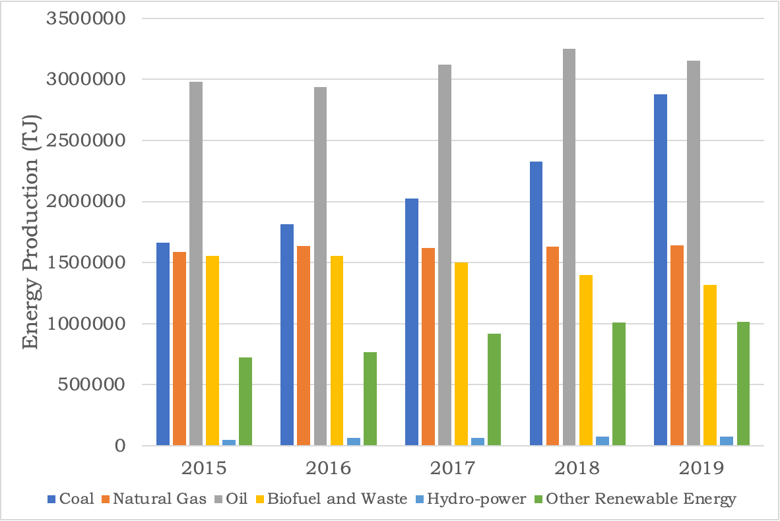
Figure 1. Total Energy Supply (TES) of Different Energy Sources from 2015-2018 in Indonesia (IEA 2020)

In the case of Indonesia, most of the national power electricity was in Java and Bali where 44.8% of electricity was produced in the accumulation of powerlines in Java and Bali followed by the power grid in Sumatera (14.7%), Sulawesi (5.6%), Kalimantan (4.4%), and Maluku and Papua (1.5%) (Pusparisa, Y. 2020). The high amount of power grid in Java and Bali was because of the high energy consumption in Java and Bali islands where the capital city of Indonesia and other major cities of Indonesia which run the economic sectors such as Surabaya located in Java Island. On the other hand, Bali is the most visited city for tourism especially for foreign destinations making the energy supply and demand in Bali high compared to other cities in Indonesia. However, the fast economic development in Indonesia initiated high energy consumption outside the Java and Bali islands. Thus, the government of Indonesia has built a new power grid outside Java and Bali Island, especially the renewable power grid plant such as Badak Solar Power Plant in Kalimantan Island, Wind Power Plant in Sidrap, South Sulawesi Island, Solar Power Plant in North Sulawesi Island, etc (SolarKita 2021).

2. Renewable energy outlook
The progress of renewable energy development in Indonesia showed progress where the trend of renewable energy development showed a positive value (IEA.org. 2020). Even though yet only a small percentage of renewable energy production has been realized, the development has been made especially in several sectors such as solar energy, wind energy, and nuclear energy where in 2015, the number of renewable energy (excluding hydropower and biofuel and waste) was approximately 8.5%, where in 2019 reached approximately 10.1%. However, the hydropower and biofuel, and waste power plants showed stagnant progress in the last couple of years due to several factors (IRENA 2019). In hydropower development, the main reason was the hydropower infrastructure was not massively improved in the last several years since the cost and investment values were high. The location of the water source was in a remote area with the limitation of transportation and public access which made the development need massive activities and costs. The government of the Republic of Indonesia has found an alternative way to improve the hydro-based power system by improving the marine-based power plant and micro hydropower plant which is considered a good move since Indonesia is an archipelagos country. Moreover, as an agricultural country, millions of basins and water irrigation systems could be exploited as the electrical power source to support the primary energy source of Indonesia, especially in the rural and remote areas (Didik et al. 2018).
On the biofuel and waste development, the development was made only for biodiesel and bioethanol which is used as a substitution for fossil fuel and not to produce electrical energy. However, the progress is still in good movement where in 2021, approximately 9.3 million liters of biodiesel have been used to substitute the use of fossil fuels (EBTKE, 2022). The other problem in the development of biofuel was the issue of food security where both biodiesel and bioethanol used food-based material. Biodiesel and bioethanol used palm oil and cassava or corn material, respectively, as the main material to produce the biofuel. The use of food-based materials is feared to disrupt food supplies in Indonesia. The trend that occurs in the development of biofuels is relatively declining from year to year. The Indonesian government must formulate in detail the regulation about the distribution of the minimum and maximum amount of food-based fuel from the biodiesel and bioethanol industry or regulate the food-waste product as the raw material for biofuel.

3. Renewable energy potential in Indonesia
Nowadays, Indonesian energy demand (without traditional biomass uses) reached 114 million tons of oil equivalent (MTOE) which supplied 40% of transportation, 36% of industry, 16% of household needs, 6% of commercial activities, and 2% of other activities (Council, 2020). The Ministry of Energy and Mineral Natural Resource or Kementerian Energi dan Sumberdaya Mineral (KESDM) have studied several sectors that could be potentially the renewable energy source shown in Table 1.
Table 1. Indonesia’ Renewable Energy Potential
Renewable Energy Sources | Total Produced Energy
Hydropower Plan | 94.3 Gigawatts
Geothermal Plan | 28.5 Gigawatts
Bioenergy  1. Biopower  2. Biogas | 23.6 Gigawatts  200.000 Barrel per hour
Solar/PV Power Plan | 207.8 Gigawatts
Windmill Plan | 60.6 Gigawatts
Ocean Power Plan | 17.9 Gigawatts

The total of renewable energy in Indonesia is 442 GW divided into several sectors (Table 1). The government of the Republic of Indonesia focused on the development of a solar power plant (SPP) where SPP contributes nearly 50% of the total renewable source coming from SPP (207.8 GW) and higher than hydropower as the most dominant renewable energy source so far in Indonesia. The development of SPP was considered a good move by the government of Indonesia since SPP become the most reliable renewable energy so far in the world. Solar photovoltaic was recorded as the fastest-growing renewable energy technology which played a major role in the future of global electricity generation (IRENA, 2019). The development of SPP in Indonesia was suitable to the characteristic of Indonesia where Indonesia is a tropical country that has long sun exposure and high sunlight intensity in all calendar years. In addition, SPP could reach remote areas which sometimes did not have electricity infrastructure.
4. Renewable Energy Development Progress in Indonesia
Talking about the potential of green energy in Indonesia, the government of Indonesia published the Primary National Energy Plant, or Rancangan Utama Energi Nasional (RUEN) in 2017. According to RUEN, the development of renewable energy in Indonesia only reached 2% of the total potential in Indonesia. To be more specific, only 8.215,5 MW of electrical production obtained from the renewable energy sector was achieved. Table 2 showed the number of electrical productions coming from renewable energy.

Table 2. Renewable Energy Production Progress in Indonesia
Renewable Energy Sources | Total Installed Power (MW) | Target Installed Power (MW) | % Goal
Hydropower Plan | 1,438.5 | 75,091 | 6.4
Geothermal Plan | 1,438.5 | 29,544 | 4.9
Mini and Microhydropower | 197.4 | 19,385 | 1.0
Bioenergy Plan | 1,671 | 32,654 | 5.1
Solar/PV Power Plan | 78.5 | 207,898 | 0.04
Windmill Plan | 3.1 | 60,647 | 0.01
Ocean Power Plan | 0.3 | 17,989 | 0.002

International Renewable Energy Agency (IRENA) in Renewable Energy Statistic 2019 reported that Indonesia has produced 8.8 GW of renewable energy which increase of approximately 508 MW of renewable electricity compared to the source in 2020. Figure 2 showed the renewable energy production reported by IRENA. The highest energy source came from hydropower which contribute 75% of renewable energy in 2021 followed by Bioenergy (21%), Solar Power (2.3%), and Wind Energy (1.7%). The result about electrical production from hydropower was strongly different from the one reported by RUEN 2017, whereas the result about other renewable energy was slightly different from the one reported by RUEN 2017.

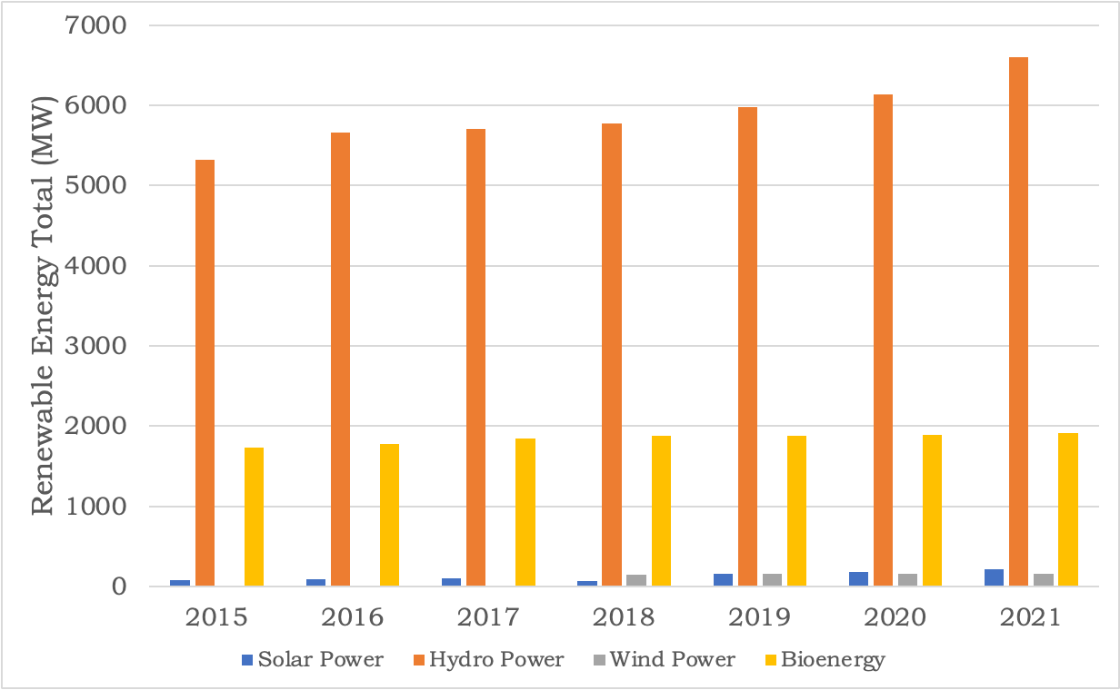
Figure 2. Renewable energy production in Indonesia reported by the International Renewable Energy Agency

In general, the amount of electrical energy produced from the renewable energy sector only fulfills approximately 14% of the total capacity of renewable energy-based power plants which reaches 64.5% (ESDM, 2017). The main reason for unsuccessful development was the high investment values in the renewable energy sector and the high energy cost per kWh from renewable energy sectors. Table 3 showed the comparison of electrical prices produced by renewable energy power plants and fossil-based power plants.
Table 3 showed that the electrical price per kilo Watts hour (kWh) from renewable energy plants is slightly higher than the price from fossil-based power plants. The high price per kWh of electricity from renewable energy power plants was because of the high investment values. Forbes (2022) reported that the value of the investment in SPP with 4 kW – 7 kW reached $15.000-$25.000 of investment (Advisor, 2022). In comparison, the electrical rate of SPP is higher than the one produced by a diesel-based power grid which is known as the most expensive fossil-based power plant.

Table 3. Levelized Cost of Energy (LCOE) of Energy
Energy Source | LCOE (Rp) per kWh | Type
Diesel-based Power Grid | 3,992 | Fossil-based Energy Source
Natural Gas and Steam-based Power Grid | 1,843 | Fossil-based Energy Source
Natural Gas Power Grid | 806 | Fossil-based Energy Source
Steam-based Power Grid | 661 | Fossil-based Energy Source
Solar/PV Power Plan | 8,786 | Renewable Energy Source
Geothermal Plan | 1,058 | Renewable Energy Source
Hydropower Plan | 388 | Renewable Energy Source

National Renewable Energy Lab (NREL) published the detail of the investment cost of SPP which is shown in Figure 3. The highest investment values were coming from the high price of the module which was the main process in SPP. However, the price of modules kept decreasing since the discovery of cheap material and highly efficient materials (Benda & Černá, 2020). Moreover, it can be seen from Figure 3 that the soft cost which become the second most costly process in the development of SPP was relatively stable every year. This cost could be well maintained by making a good policy or regulation by the government to cut the soft cost which is mostly related to sales tax, compensation, or profit (NREL, 2020).
5. Energy Policy in Indonesia and Future Direction of Energy Development
The government of the Republic of Indonesia has started the transition of energy from fossil fuel to renewable fuel. The story began by releasing law No, 30 of 2007 about Energy. Another regulation is Presidential Regulation No. 79 of 2014 where the regulation put 23% of primary energy sources coming from renewable energy sources in 2025 and 31% in 2050. The presidential regulation become the base of the further movement where the government arranged the primary national energy planning or RUEN in 2017 which was supported by the presidential regulation no. 22 of 2017.
According to RUEN, Indonesia will focus on the development of SPP in the future where 207.8 GW become the target of development in 2050. The main reason for the development of SPP was the reliability of SPP which aligns with the characteristics of the Republic of Indonesia. Through 2025, the government of the Republic of Indonesia put 3.6 GW as the checking point to evaluate the progress of development. However, the progress seems to have left behind the target where only 0.08% of the target was utilized in 2021 (Suparwoko & Qamar, 2022).
The main reason why the utilization rate was low is because the SPP was considered an expensive technology. Furthermore, SPP was always compared with coal-based power plant which was strongly cheaper. However, the sustainability and environmental effects of coal-based power plants were never placed in the policy decision where most of the parliament only taught about the financial advantages.
The target of 3.6 GW in 2025 and 207.8 GW in 2050 could not be achieved if the government does not open for private or community societies. The successful of energy transition in Indonesia should be began by the fully support from the citizen. This means that the transition should be a massive movement from the government and citizen where the citizen willingness become the key roles. The successful participation from citizen could make the energy transition easier. The local people could contribute and invest their own money to the new and renewable energy sector. Kalkbrenner and Roosen (2016) reported that the social movement from citizen participation in energy transition played the important roles in the local level energy transition (Kalkbrenner and Roosen 2016).
Furthermore, the government as the power source should prepare for making better regulations to cultivate the willingness of people in Indonesia to reach the goal. Learning from another country such as the United States, the government could regulate several advantages which made private, or community sectors want to transform and invest in green energy infrastructure. One of the examples is giving a tax-free or tax deduction for people who contribute to the development of green energy systems. To be specific in the private sector, the government could give a regulation for the green company to sell their green electricity to the community which provides an additional value in the investment of SPP. The successful of cultivation about green energy could reduce the responsibility of the government of Indonesia to invest a high number of monies in green infrastructure and on the other hand also reach the target of energy transition in 2050.
The government of the Republic of Indonesia also revised regulation related to the solar panel. The Ministerial Regulation of the Minister of Energy and Mineral Resource No. 49 of 2018 which only cover 65% of total exported electricity was revised with the Ministerial Regulation of the Minister of Energy and Mineral Resources No. 26 of 2021. In the first release, the Regulation No 26 of 2021 would cover 100% of total exported electricity which in frame could stimulate the solar energy investment (EDSM, 2018). However, the new regulation of 26 of 2021 still in hold where several regulations should be considered before fully implemented. One of most concern was the elimination planning of export of the electricity which could be the most stimulation movement of this new regulation (Dwi, 2023). The government planned that the owner of solar panels should use all the produced electricity by their own and do not expect to sell the electricity to the government. This regulation was opposite with the main plan of government to boost the green energy investment and made the solar energy investment is not economically feasible. The failure of regulation potentially failed to accelerate the willingness of people in Indonesia to contribute to installing the SPP. Thus, the target of 23% of green energy from renewable energy could be just a statement.
Setyawati (2020) have reported that approximately 71% of 987 PLN consumer have a high willingness to transform their electricity to SPP (Setyawati, 2020) but with better regulation, especially in the electrical export rate and an easy protocol installation. Based on the regulation of 26 of 2021, there are lots of steps and administrations should be made before starting the installation of solar panel in the house. It could be made that the installing of solar energy was complicated and highly cost investment. Therefore, the government needed to redesign the better regulation specially to support the green energy investment to stimulate the energy transition in the community. The good regulation should make the government reached the goal easier compared to achieve by themselves.

Conclusion
Renewable energy has shown a promising development in Indonesia where the trend moved to a higher electrical production annually. Solar power plant (SPP) was aimed as the main core of electrical generation based on RUEN in 2025. However, better regulation and clear protocol should be made to stimulate the willingness of consumers to participate in the renewable energy transformation in Indonesia. The better electrical export rate could be a starting point to show that the green energy sector is profitable for everyone.

Acknowledgements
The authors thank Dinas Energi dan Sumberdaya Mineral Provinsi Sumatera Selatan for providing an input in this present paper.

Author Contributions
I.K.: Conceptualization, Supervision, Project Administration, R.I.; Writing – Editing, Data Analysis, Validation, R.F.; Editing, Language Improvement, A.H.; Conceptualization, Supervision, Writing original draft, Data Visualization. All authors have read and agreed to the published version of the manuscript.

References
Advisor, F. (2022). How Much Do Solar Panels Cost? https://www.forbes.com/advisor/home-improvement/average-cost-of-solar-panels/ Accessed on 21 May 2023
Ahdiat, A. (2022). Pertumbuhan PLTU Batu Bara Indonesia Tertinggi di G20. THe coal fired power plant growth in Indonesia is the highest in the G20. https://databoks.katadata.co.id/datapublish/2022/11/14/pertumbuhan-pltu-batu-bara-indonesia-tertinggi-di-g20 Accessed on 13 May 2023
Benda, V., Černá, L. (2020). PV cells and modules – State of the art, limits and trends. Heliyon, 6(12), e05666; https://doi.org/10.1016/j.heliyon.2020.e05666
European Commission (2023). Paris Agreement. https://climate.ec.europa.eu/eu-action/international-action-climate-change/climate-negotiations/paris-agreement_en. Accessed on 11 May 2023
Secretarial General of National Energy Council (2020). Indonesia Energy Outlook 2019. https://www.esdm.go.id/assets/media/content/content-outlook-energi-indonesia-2019-bahasa-indonesia.pdf; Accessed on 12 May 2023.
Didik, H., Bambang, P. N., Asep, S., Purwanto, Y. A., (2018). Sustainability Challenge of Micro Hydro Power Development in Indonesia. IOP Conf. Series: Earth and Environmental Science 147. 012031. https://doi.org/10.1088/1755-1315/147/1/012031
Dwi, M. F. (2023). Fix! Aturan Ekspor Listrik PLTS Atap ke PLN Dihapus. C. Indonesia. https://www.cnbcindonesia.com/news/20230310083708-4-420504/fix-aturan-ekspor-listrik-plts-atap-ke-pln-dihapus. Accessed on 19 June 2023.
EBTKE, Direktorat Jenderal Energi Baru dan Terbarukan dan Konservasi Energi (2022). Capaian Kerja Tahun 2021 dan Program Kerja 2022 Sektor ESDM. The annual progress plans of Ministry of Energy and Natural Resource of Republic of Indonesia in the year of 2021 and the plan for 2022 programs. , https://ebtke.esdm.go.id/post/2022/01/13/3052/capaian.kinerja.tahun.2021.dan.program.kerja.2022.sektor.esdm. Accessed on 10 May 2023.
EDSM, Kementerian Energi dan Sumber Daya Mineral, Republik Indonesia (2018). Peraturan Menteri Energi dan Sumber Daya Mineral Republik Indonesia Nomor 48 Tahun 2018 tentang Penetapan Objek Vital Nasional Bidang Energi dan Sumber Daya Mineral. https://peraturan.bpk.go.id/Home/Details/142948/permen-esdm-no-48-tahun-2018. Accessed on 10 May 2023
ESDM, Kementerian Energi dan Sumber Daya Mineral, Republik Indonesia (2017). Rencana Umum Energi Nasional. https://www.esdm.go.id/assets/media/content/content-rencana-umum-energi-nasional-ruen.pdf. Accessed on 11 May 2023
Hakim, R. R. A. (2020). Model Energi Indonesia, Tinjauan Potensi Energi Terbarukan untuk Ketahanan Energi di Indonesia: Literatur Review. ANDASIH Jurnal Pengabdian kepada Masyarakat, 1, 1-10.
Halawa, E. E. H., Sugiyatno. (2001). Estimation of global solar radiation in the Indonesian climatic region. Renewable Energy, 24(2), 197-206. https://doi.org/https://doi.org/10.1016/S0960-1481(00)00196-8
IEA, International Energy Agency (2020). Indonesian Total Energy Supply (TES) by Source. https://www.iea.org/countries/indonesia. Accessed on 07 May 2023
IESR, Institute for Essential Services Reform (2017). Energi Terbarukan: Energi untuk Kini dan Nanti. https://www.iesr.or.id/wp-content/uploads/2018/11/COMS-PUB-0001_Briefing-Paper-1_Energi-Terbarukan.pdf. Accessed on 1 May 2023
IRENA, International Renewable Energy Agency (2019). Renewable energy statistics 2019. Abu Dhabi, United. https://www.irena.org/publications/2019/Jul/Renewable-energy-statistics-2019. Accessed on 25 April 2023
Kalkbrenner, B. J., Roosen, J. (2016). Citizens’ willingness to participate in local renewable energy projects: The role of community and trust in Germany. Energy Research & Social Science, 13, 60-70. https://doi.org/10.1016/j.erss.2015.12.006.
NREL, National Renewable Energy Laboratory (2020). U.S. Solar Photovoltaic System and Energy Storage Cost Benchmark: Q1 2020. https://www.nrel.gov/docs/fy21osti/77324.pdf; Accessed on 27 April 2023
OurWorldinData. (2022). Annual percentage change in renewable energy generation, 1966 to 2021. https://ourworldindata.org/grapher/annual-percentage-change-renewables?tab=chart&country=ISL~Other+South+America+%28BP%29. Accessed on 25 April 2023
Setyawati, D. (2020). Analysis of perceptions towards the rooftop photovoltaic solar system policy in Indonesia. Energy Policy, 144, 111569. https://doi.org/https://doi.org/10.1016/j.enpol.2020.111569
Suparwoko, Qamar, F. A. (2022). Techno-economic analysis of rooftop solar power plant implementation and policy on mosques: an Indonesian case study. Scientific Reports, 12(1), 4823. https://doi.org/10.1038/s41598-022-08968-6
Tacconi, L. (2018) Indonesia’s NDC bodes ill for the Paris Agreement. Nature Climate Change, 8(10), 842-842; https://doi.org/10.1038/s41558-018-0277-8

